**Cloudwatch**

Learn cloudwatch and try the handson to set alarm in cloudwatch when instance

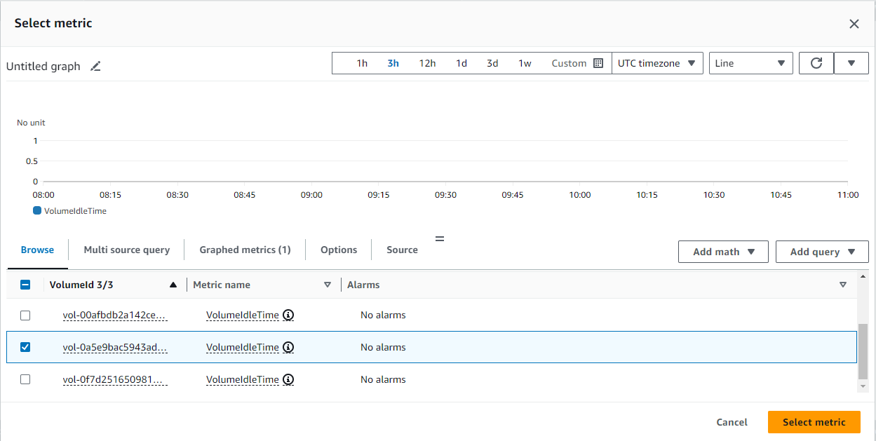

Select a metric volumeidletime of instance which helps to get the data, The total number of seconds in a specified period of time when no read or write operations were submitted on volume. Note: Not supported with Multi-Attach enabled volumes

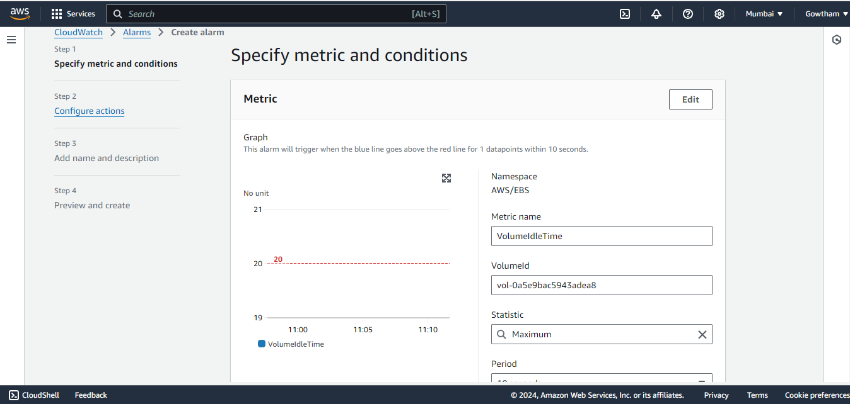

Setting volume idle time as 20 seconds and ask the cloudwatch to check the volume for each 10 seconds

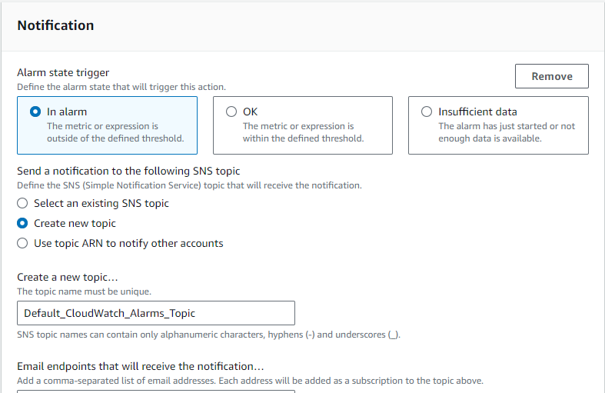

cloud watch will send the alarm message to given mail-id with the help of sns(simple notification service) if the given state is triggered

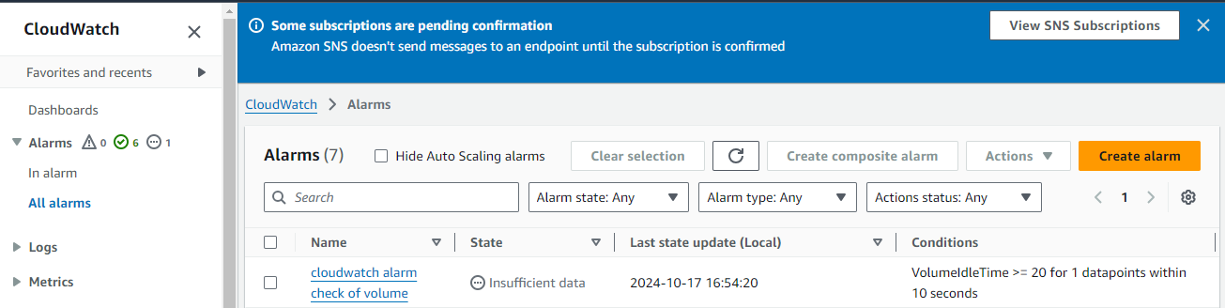

Alarm is created but it shows insufficient data because we need to give permission in give mail to receive notifications from aws or else it won’t send a message

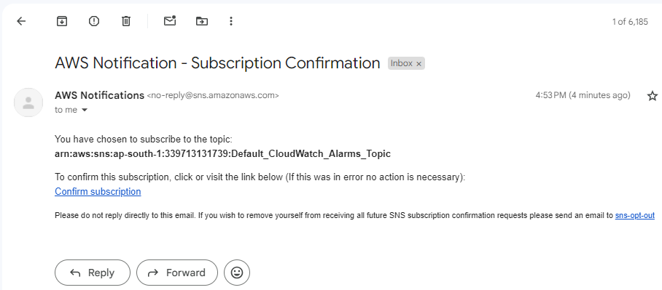

Give confirm subscription

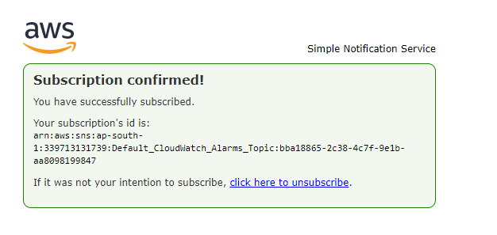

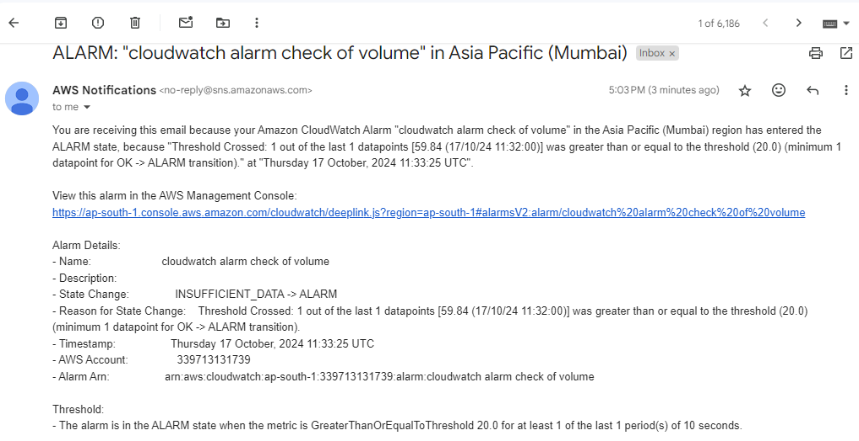

We received the mail why because the volume is not in use for more then 20 seconds and thats why alarm triggered